Using Switch in React->

1. How we use Switch-

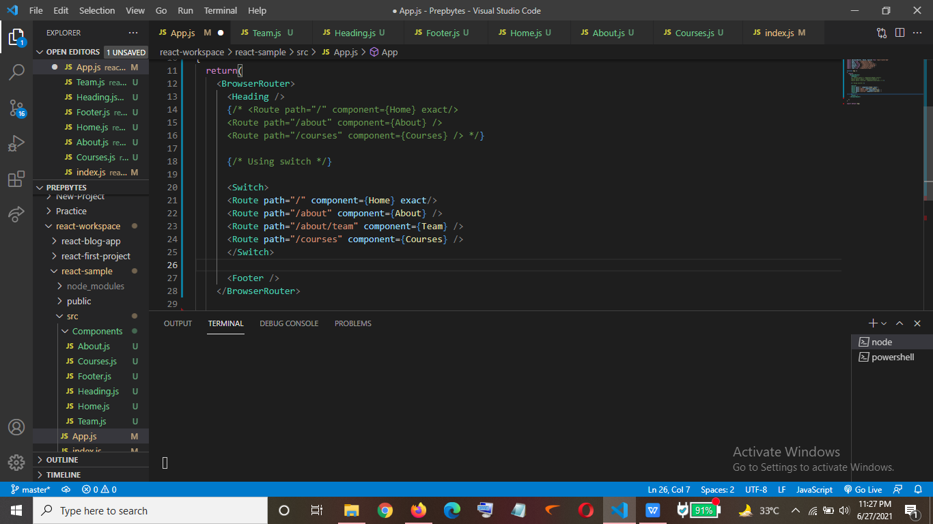

Output->

1. Home Page (Url - > “ / ”)

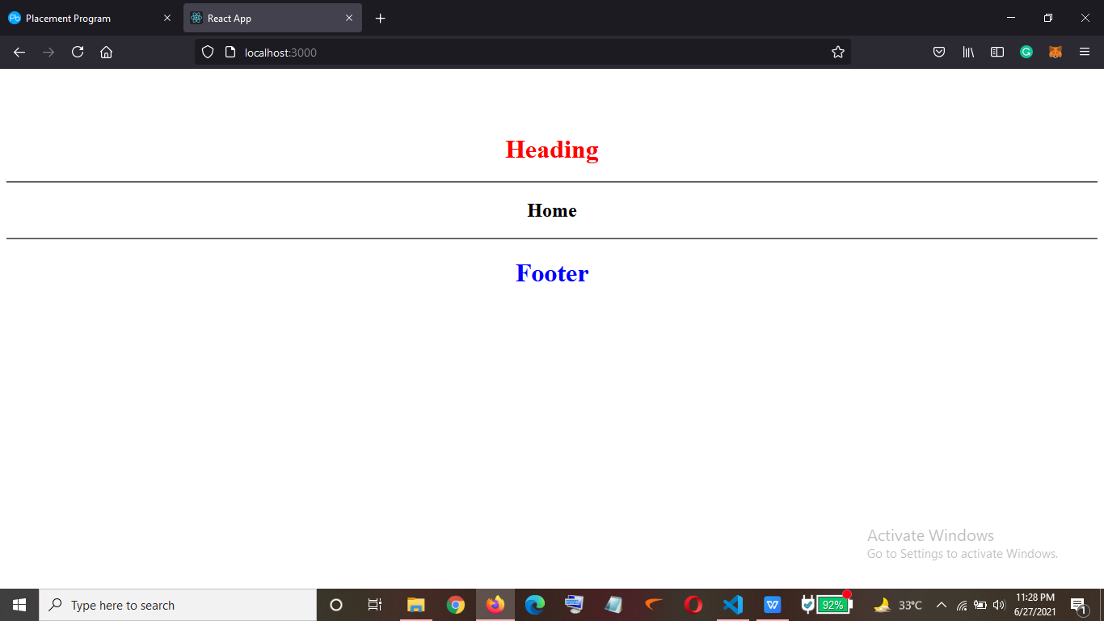

1. If now I hit (url-> “ about/team ”) I should be getting the team’s page but About page is rendered

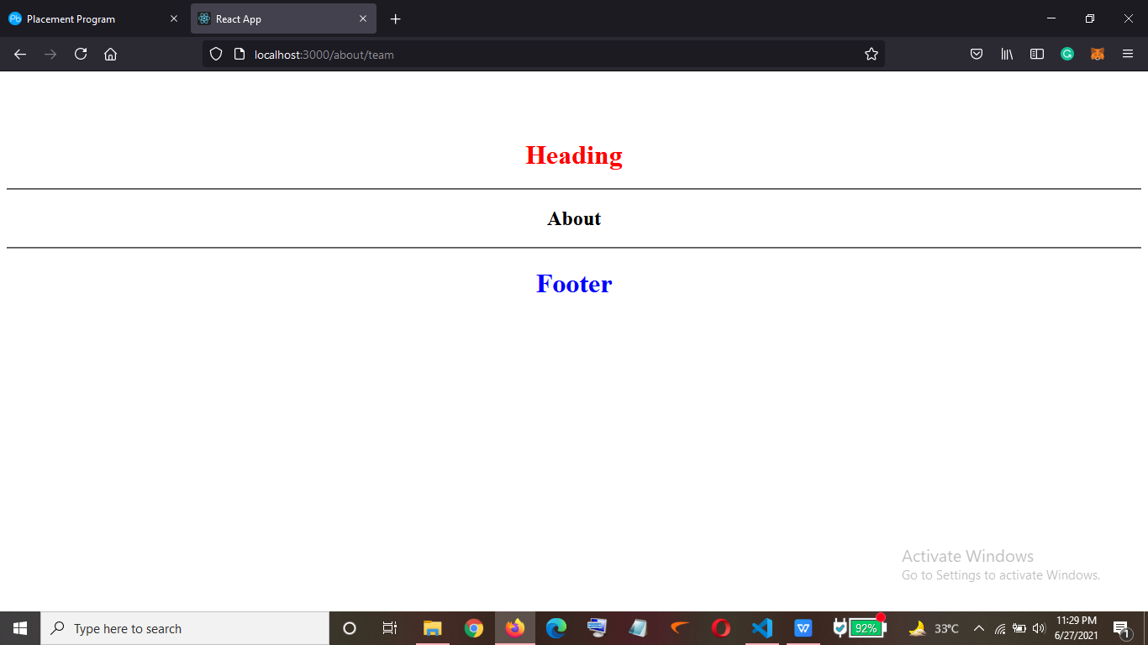

1. To solve this -> (We put the more specific urls on the top so that it can match the whole url instead of just checking the first similarity in the urls)

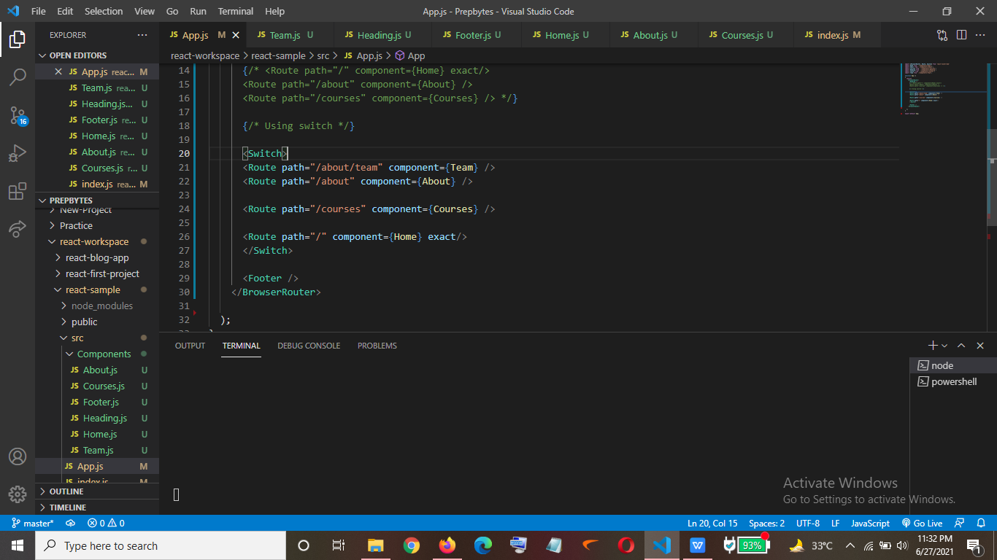

Output->

1. For “ about/team ” we are getting the Team Page displayed successfully.

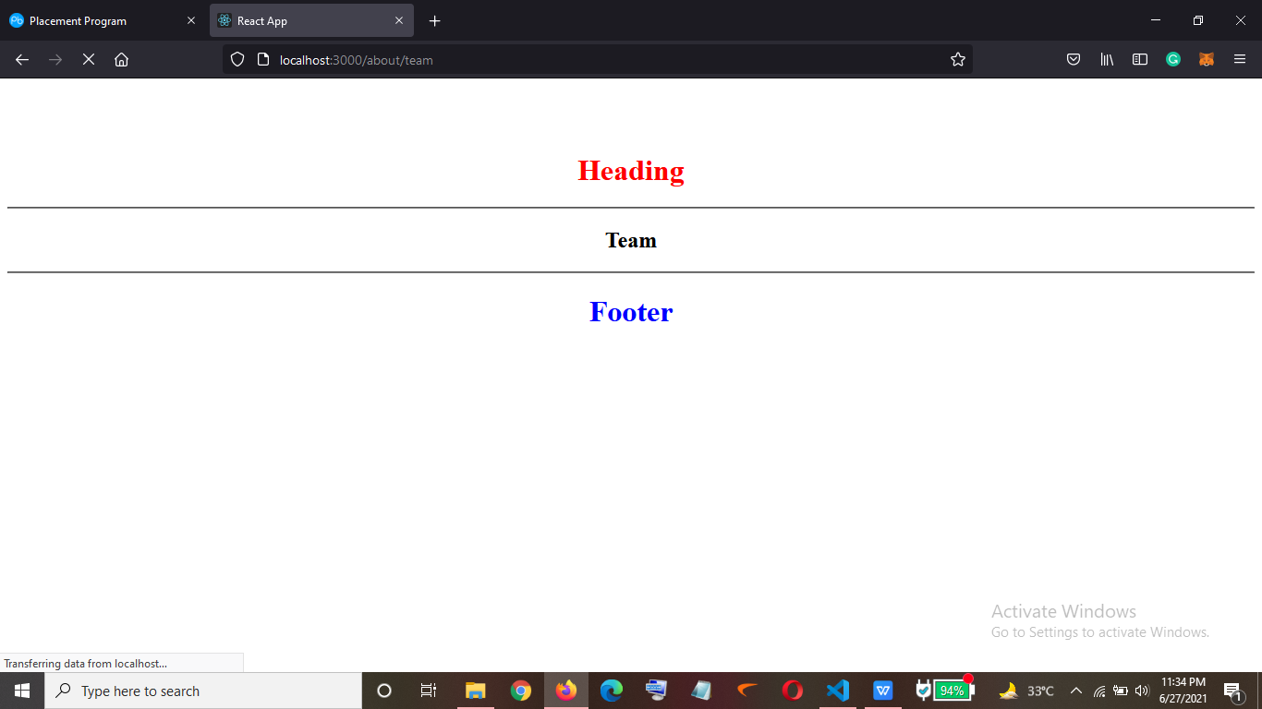

1. For “ /about ” ->

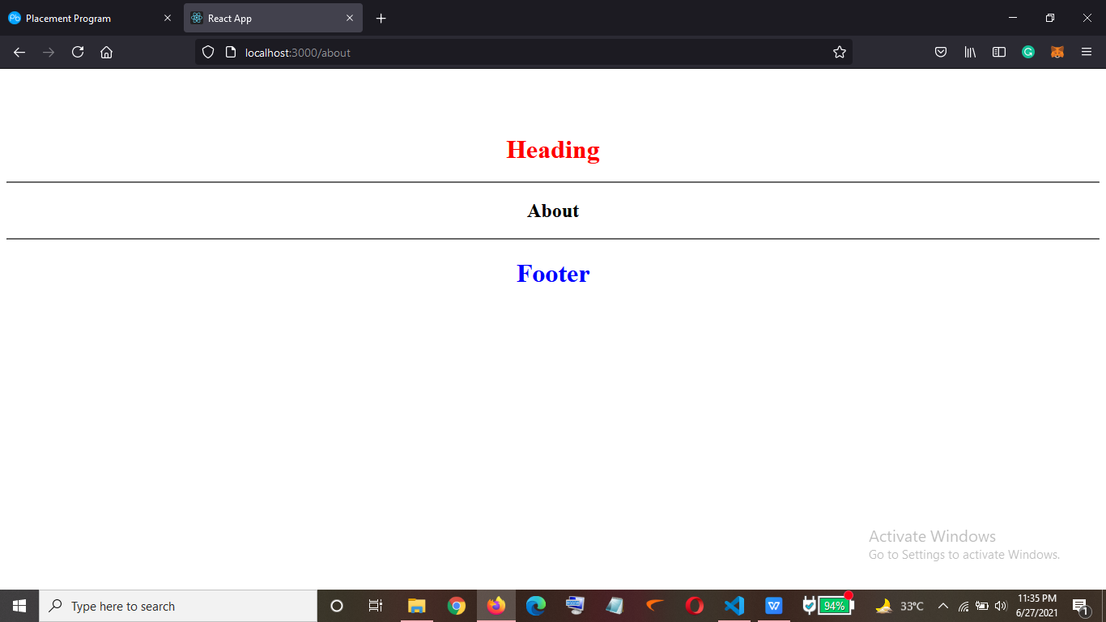

1. For “ /courses ” ->

